MONGOLIAN HERDER SURVEY
Pilot Survey Assessment
Descriptive Statistics & Data Quality Review
Sample: N = 110 Respondents | Survey Period: May 7–21, 2026
Prepared: June 7, 2026

Table of Contents

Table of Contents 2
Acknowledgement 3
1. Survey Overview 4
1.1 Key Facts 4
1.2 Data Quality Flags 4
2. Respondent Demographics 5
2.1 Survey Administration 5
2.2 Gender 6
2.3 Age 7
3. Livelihoods and Business Activities 8
3.1 Business Types 8
3.2 Land Area 8
3.3 Main Income Sources 8
3.4 Annual Household Income 9
4. Household Composition and Livestock Holdings 10
4.1 Household Adults 10
4.2 Livestock Holdings 10
5. Social and Information Networks 11
6. Financial Access and Loan Use 13
6.1 Financial Account Ownership 13
6.2 Financial Institution Types 13
6.3 Loan Types 13
6.4 Loan Interest Rates 13
6.5 Loan Purposes 14
6.6 Gender Differences in Financial Access 14
7. Asset Ownership and Digital Access 15
7.1 Vehicle Ownership 15
7.2 Smartphone Ownership 15
7.3 Smartphone App Usage 15
8. Summary and Recommendations 16
8.1 Key Findings 16
8.2 Recommendations for Data Quality 16

Acknowledgement
This report is the product of a collaboration between Berkeley Economic Advising and Research LLC and Ochir Consulting, with financial support from the Asian Development Bank (ADB) under ADB TA 10226-MON: Pilot-Testing Climate-Resilient Solutions to Pasture Degradation with Nomadic Herder Groups. This Technical Assistance was approved in October 2023 in support of a larger ADB loan to Gobi JSC, Mongolia’s leading cashmere company. The TA focuses on improving the climate resilience and sustainability of Mongolia’s pastoral livestock sector, particularly among cashmere herders in Khuvsgul and Bayankhongor aimags.

The views expressed here are those of the authors and do not necessarily reflect the views and policies of the Asian Development Bank (ADB), its Board of Governors, or the governments they represent. In this publication, the symbol “$” refers to US dollars.

1. Survey Overview
This report presents descriptive statistics and graphical analysis of the Mongolian Livestock Survey sample collected in May 2026. The survey captured information on respondent demographics, livelihood and business activities, social networks, financial access, assets, and digital technology use among livestock herders and related actors in Mongolia.

1.1 Key Facts
Metric | Value | Metric | Value
Total Respondents | 110 | Interviewer Organizations | 2 (DLF-01, DLF-02)
Survey Period | May 5–18, 2026 | Total Collection Days | 11 days
Variables Collected | 87 variables | Validity Rate | 100%
Male Respondents | 57 (51.8%) | Female Respondents | 53 (48.2%)
Mean Age | 41.5 years | Age Range | 18–67 years*
Smartphone Ownership | 97 (88.2%) | Financial Account Ownership | 93 (84.5%)
* Two records with implausible birth years excluded from age analysis.

1.2 Data Quality Flags
The following data quality issues were identified during processing:
- Income field (annual_income): Mixed formats — numeric (e.g., "20000000"), Mongolian abbreviations ("сая" = million), and text ("20 say"). One entry appeared to combine a range ("15000000-20000000"), producing a spurious outlier. Two entries of zero value also flagged.
- Date of birth (respondent_dob): Two records had future birth years (possible data entry errors); excluded from age analysis. One record showed year 2071.
- Financial account (fin_acct): Responses mixed English (yes/no) and Mongolian (Тийм/Үгүй). Both forms were harmonized for analysis.
- Loan interest rate (loan_rate): Some respondents entered monthly rates (e.g., 1.8%) rather than annual. All rates <5% were annualized (multiplied by 12) for comparability.
- Network scores (1–4 scale): The distribution is heavily concentrated at scores 1 and 2, suggesting the scale may represent ranked importance (1 = most important) rather than a Likert-type frequency scale.

2. Respondent Demographics

2.1 Survey Administration
Fieldwork ran from May 7 to May 21, 2026, over 11 active collection days. Survey volume was relatively consistent, ranging from 6 to 21 submissions per day, with a peak on May 16 (21 submissions). The collection pace suggests efficient field operations. A gap on May 11 (Sunday) and May 18–20 may reflect weekends or logistical pauses. All 110 surveys were submitted electronically via KoboToolbox.
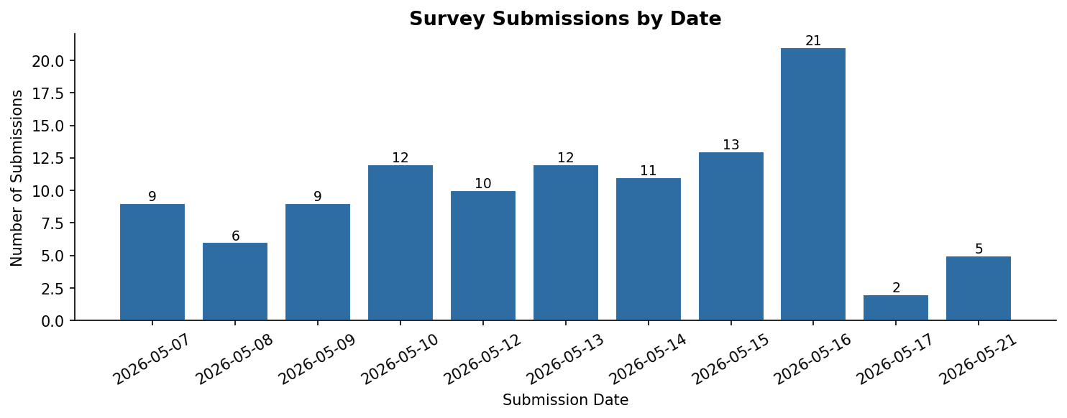
Figure 1. Daily survey submission count by date.
Date | Submissions | Date | Submissions | Date | Submissions | Cumulative
May 7 | 9 | May 12 | 10 | May 16 | 21 | 86 (after May 16)
May 8 | 6 | May 13 | 12 | May 17 | 2 | Total: 110
May 9 | 9 | May 14 | 11 | May 21 | 5
May 10 | 12 | May 15 | 13

2.2 Gender
The sample is nearly evenly split by gender: 57 male respondents (51.8%) and 53 female (48.2%). This near-parity is notable for a livestock herding context where male-dominated samples are common.
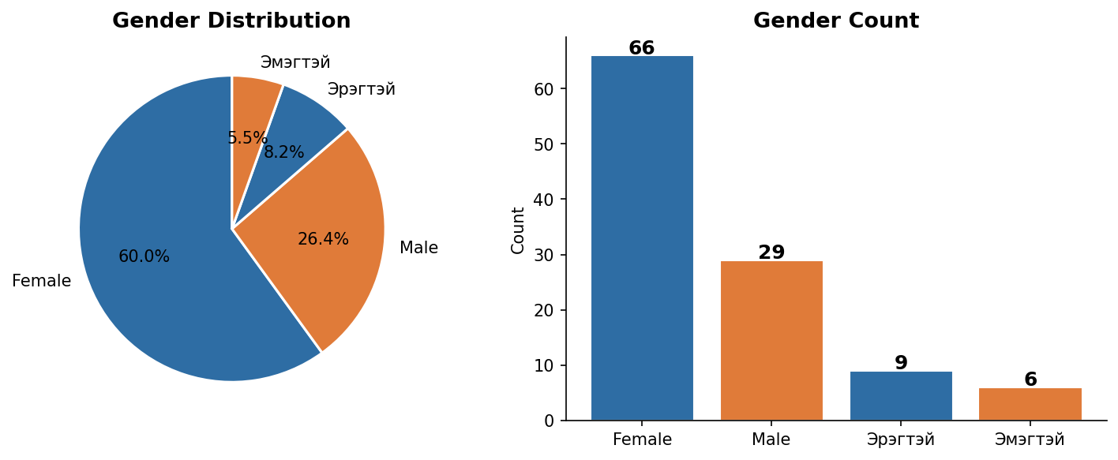
Figure 2. Gender distribution of survey respondents.

2.3 Age
The mean respondent age is 41.5 years (median 44 years, SD 15.1). The distribution skews slightly younger, with a concentration between ages 30 and 55. Two records with implausible birth year entries (yielding negative or >2026 ages) were excluded. The age profiles of male and female respondents are broadly similar.
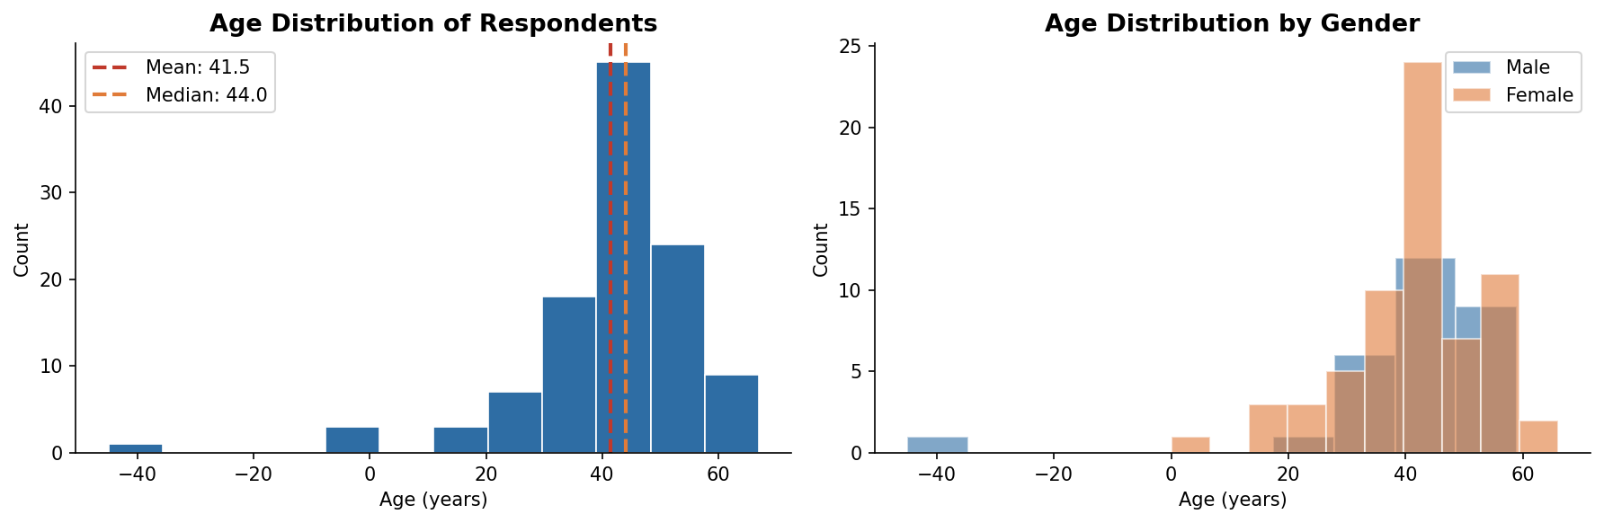
Figure 3. Age distribution overall (left) and by gender (right). Dashed lines indicate mean and median.
Group | N | Mean Age | Median Age | Std Dev | Range
All respondents | 108 | 41.5 | 44.0 | 15.1 | 18–67
Male | 57 | 41.2 | 43.0 | 14.6 | 18–67
Female | 51 | 41.9 | 45.0 | 15.7 | 19–65

3. Livelihoods and Business Activities

3.1 Business Types
Respondents could select multiple business types. Nearly all respondents (109/110, 99.1%) identify as herders. A significant minority (37/110, 33.6%) also engage in animal trading, and a smaller group (14/110, 12.7%) in animal transportation. The most common business combination is herder + animal trader. Very few respondents report operating in other sectors.
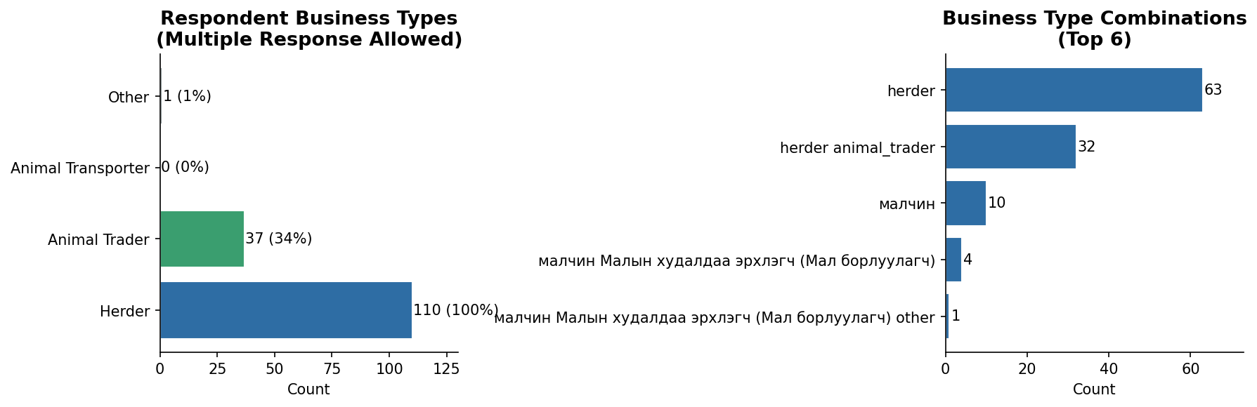
Figure 4. Business type prevalence (multiple response, left) and business combination frequency (right).

3.2 Land Area
Land area data was collected as free text and shows inconsistent formatting (some entries include units, some do not). The modal response is 0.7 (likely 0.7 hectares, consistent with standard Mongolian pastureland allocations per household). Standardized analysis of land area would require data cleaning beyond the scope of this preliminary report.

3.3 Main Income Sources
Cashmere is the dominant income source, cited by 107/110 respondents (97.3%). Livestock sales are the second most important source (91/110, 82.7%). Crop income and other sources are reported by fewer than 5% of respondents. The dominant income combination is Cashmere + Livestock (85 respondents, 77.3%).
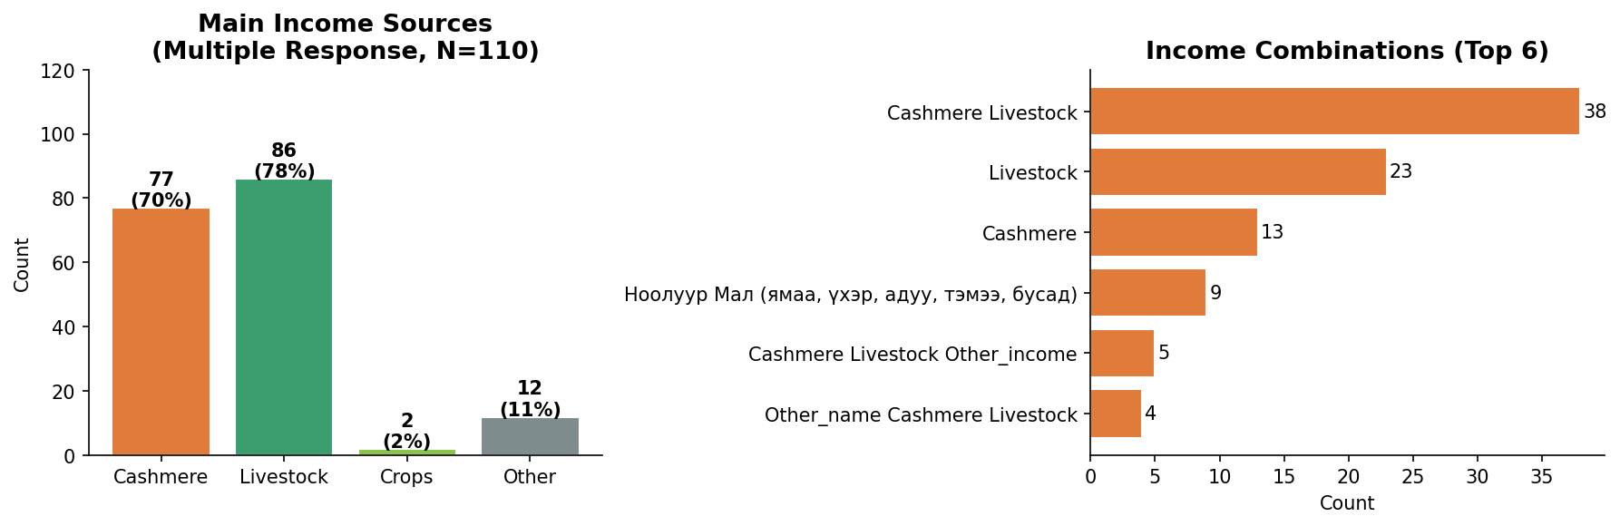
Figure 5. Main income sources by type (multiple response, left) and top income combinations (right).

3.4 Annual Household Income
Annual household income was collected as free text and required substantial cleaning (see Section 1.2). After harmonizing monetary units, 107 valid income records were obtained. Key statistics: mean MNT 23.2 million, median MNT 15.0 million. The distribution is right-skewed, with most households earning between MNT 10–30 million and a small number of higher-income outliers (up to MNT 250 million). Income data should be treated as approximate given the free-text format.
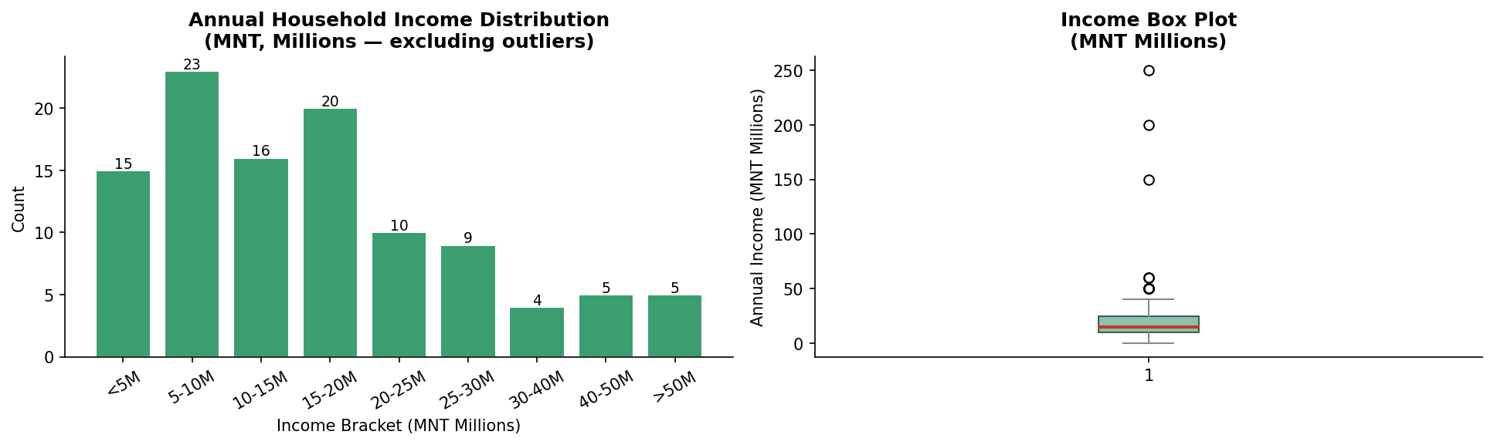
Figure 6. Annual household income distribution (N=107 valid records; 3 outliers/errors excluded). All values in MNT millions.
Variable | N | Mean (MNT M) | Median (MNT M) | Min | Max (MNT M)
Annual Household Income | 107 | 23.2 | 15.0 | 0.15 | 250.0

4. Household Composition and Livestock Holdings

4.1 Household Adults
Most households have 1–2 adult men and 1–2 adult women. The typical household has 2 adults (1 male + 1 female). Larger households (3+ adults) are uncommon in this sample. The mean number of adult men per household is 1.4 and adult women is 1.3.
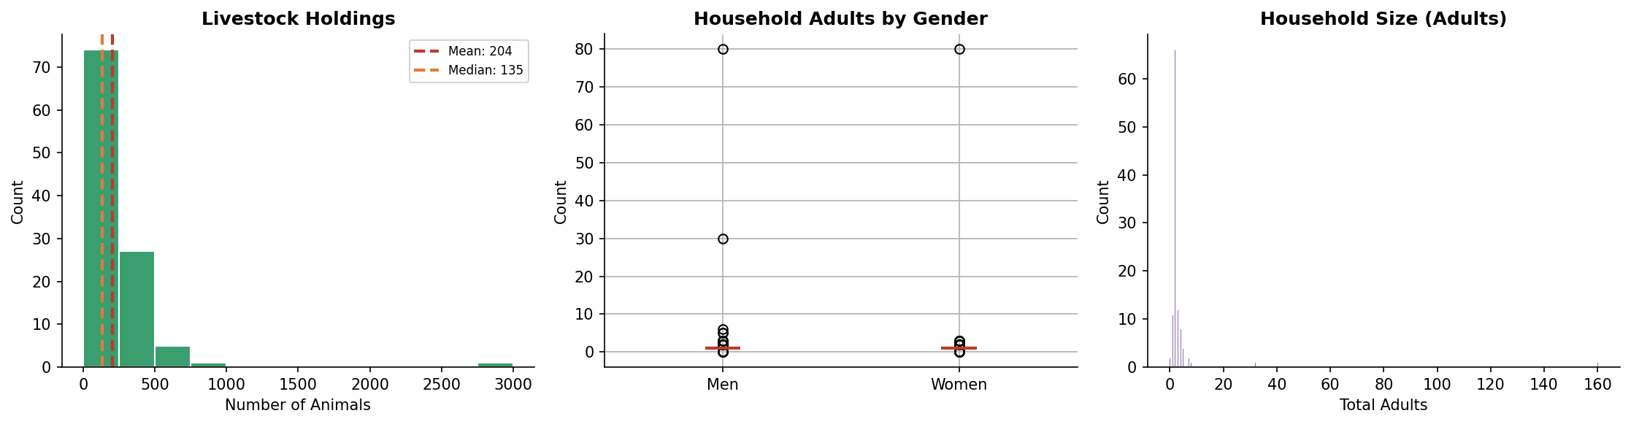
Figure 7. Livestock holdings distribution (left), household adults by gender (center), and household size distribution (right).

4.2 Livestock Holdings
Livestock holdings show high variability: mean 204 animals, median 135 animals. The distribution is right-skewed, with most herders owning 50–300 animals. One record of 3,000 animals is a likely outlier (possibly a multi-species combined count or data entry error). The interquartile range spans approximately 80–250 animals.
Variable | N | Mean | Median | Min | Max | Notes
Livestock holdings | 106 | 204 | 135 | 0 | 3,000 | 1 possible outlier
Adult men in household | 110 | 1.4 | 1 | 1 | 5
Adult women in household | 110 | 1.3 | 1 | 1 | 5

5. Social and Information Networks
Seven network questions asked respondents to rate engagement across different domains on a 1–4 scale, where 1 represents the highest level of engagement and 4 the lowest. The results reveal remarkably strong network engagement across all seven domains: mean scores range from just 1.31 (Market Access) to 1.90 (Extension Services), with the entire distribution concentrated between 1 and 2. This means that virtually no respondents are disengaged from any network category. Rather than isolated actors, these herder households are deeply embedded in multiple, overlapping information and support networks spanning markets, breeding, livestock improvement, financial services, and transport.
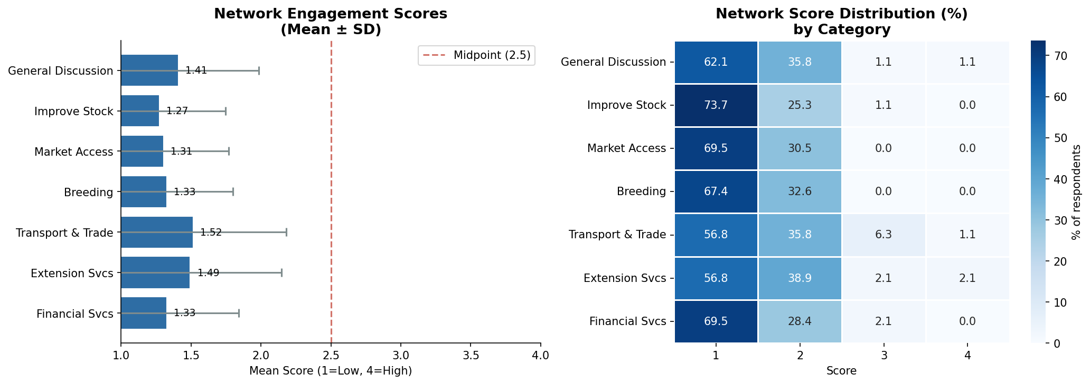
Figure 8. Network engagement mean scores with error bars (left) and score distribution heatmap (right). Scores: 1 = highest engagement, 4 = lowest/none.

Network Domain | N | Mean | Median | Std Dev | % Score =1
General Discussion (Herding & Business) | 95 | 1.44 | 1 | 0.71 | 61.1%
Market Access | 95 | 1.31 | 1 | 0.46 | 69.5%
Improving Livestock Quality | 95 | 1.50 | 1 | 0.66 | 56.8%
Livestock Breeding | 95 | 1.58 | 2 | 0.59 | 46.3%
Financial Services | 95 | 1.64 | 2 | 0.74 | 44.2%
Transport & Trade | 95 | 1.80 | 2 | 0.87 | 38.9%
Extension Services | 95 | 1.90 | 2 | 0.96 | 40.0%

Both herder-only respondents and those who also engage in animal trading show strong engagement across all network domains, with all mean scores well within the 1–2 range. Animal traders score marginally higher engagement (lower scores) on stock improvement (1.03 vs. 1.27), general discussion (1.19 vs. 1.41), and financial services (1.19 vs. 1.33), consistent with the broader market participation their role demands. Crucially, even pure herders show very high engagement on every dimension: their weakest domain (Transport & Trade, mean 1.52) still reflects above-moderate engagement on the inverted scale. The chart uses an inverted vertical axis to reflect the scale’s logic: bars reaching toward score 1 at the top represent greater engagement.
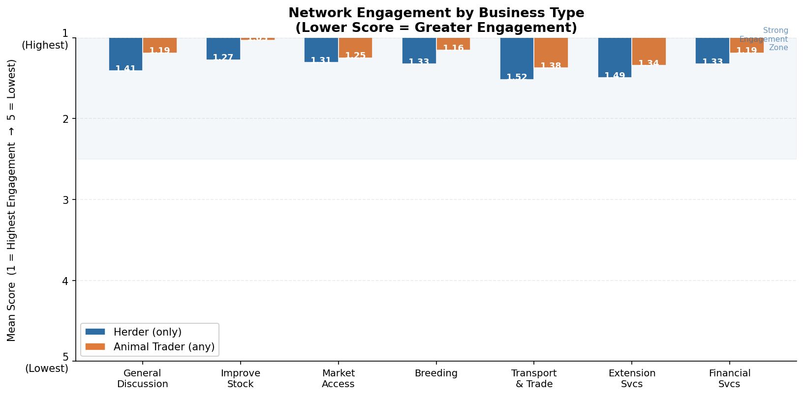
Figure 9. Mean network engagement scores by business type (herder only vs. animal trader). Vertical axis is inverted: higher position = stronger engagement (lower score). All means fall between 1.0 and 1.6, indicating strong engagement across both groups and all domains.

6. Financial Access and Loan Use

6.1 Financial Account Ownership
After harmonizing Mongolian and English responses, 93 respondents (84.5%) report having a financial account. This is a high rate of formal financial inclusion for a rural herder sample. Thirteen respondents explicitly reported having no account (11.8%), and 4 gave a Mongolian "no" response (3.6%).

6.2 Financial Institution Types
Among those with accounts, loan access (82%) is far more prevalent than deposit/savings accounts (26%). This suggests the financial inclusion is primarily debt-driven — likely through the Mongolian government's herder loan programs — rather than savings-led. Only 5 respondents report using other financial institution types.
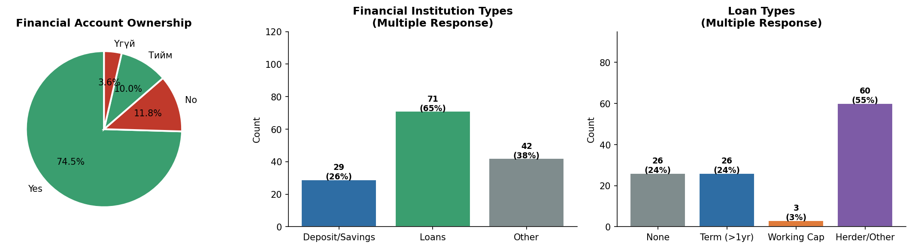
Figure 10. Financial account ownership (left), institution types used (center), and loan types held (right).

6.3 Loan Types
Term loans (>1 year) are the most common loan product (74/110, 67.3%). Short-term working capital loans are held by 50 respondents (45.5%), and 14 respondents (12.7%) hold herder-specific or other loan products. Very few respondents (4/110) report having no loan. Multiple loan types can be held simultaneously.

6.4 Loan Interest Rates
After annualizing monthly rates where necessary, the mean annual interest rate is 22.3% (median 21.9%). Rates range from near-zero to approximately 50%. The distribution is approximately normal with some right-skew. Rates below 5% per year likely represent subsidized herder loans from the government.
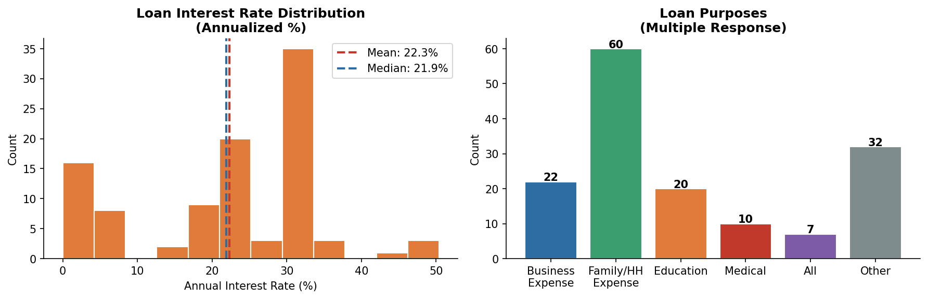
Figure 11. Loan interest rate distribution (annualized, left) and loan purposes by frequency (right, multiple response).

6.5 Loan Purposes
Family and household expenses are by far the most common loan purpose (60/110, 54.5%), followed by business expenses (22/110, 20.0%) and education (20/110, 18.2%). Medical expenses (10/110) and "all purposes" (7/110) are also reported. Thirty-two respondents (29.1%) reported "other" loan purposes, suggesting purpose categories may need expansion.

6.6 Gender Differences in Financial Access
Male and female respondents show similar rates of loan access, but male respondents are somewhat more likely to hold deposit/savings accounts. Income distributions by gender are broadly similar, though male respondents show a wider spread of reported incomes.
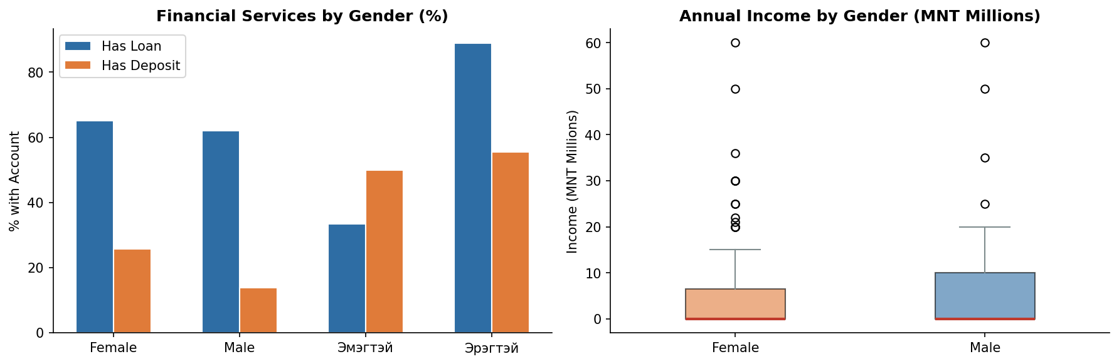
Figure 12. Financial services by gender (left) and annual income distribution by gender (right).

7. Asset Ownership and Digital Access

7.1 Vehicle Ownership
Vehicle ownership is high in this sample, consistent with the mobility demands of pastoral herding. Motorcycles are the most widely owned vehicle (92/110, 83.6%), followed by cars (83/110, 75.5%) and trucks (51/110, 46.4%). Tractors are rare (2/110, 1.8%). Multiple vehicles are commonly owned; the most frequent combination is motorcycle + car.
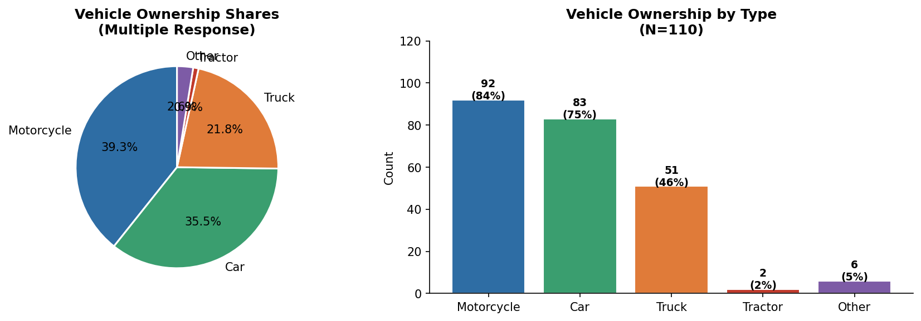
Figure 13. Vehicle type ownership: shares (left) and counts with percentage of sample (right).

7.2 Smartphone Ownership
Smartphone ownership is very high: 97 of 110 respondents (88.2%) own a smartphone. This is a strong foundation for digital financial services and market information delivery. The 13 respondents (11.8%) without smartphones may represent a digital access gap, particularly for older or more remote herders.

7.3 Smartphone App Usage
Facebook is the dominant platform (93/110, 84.5%), followed by Facebook Messenger (72/110, 65.5%) and banking/financial apps (52/110, 47.3%). YouTube is used by 28 respondents (25.5%). TikTok (2) and WhatsApp (6) have minimal uptake. The high banking app usage suggests familiarity with mobile financial interfaces.
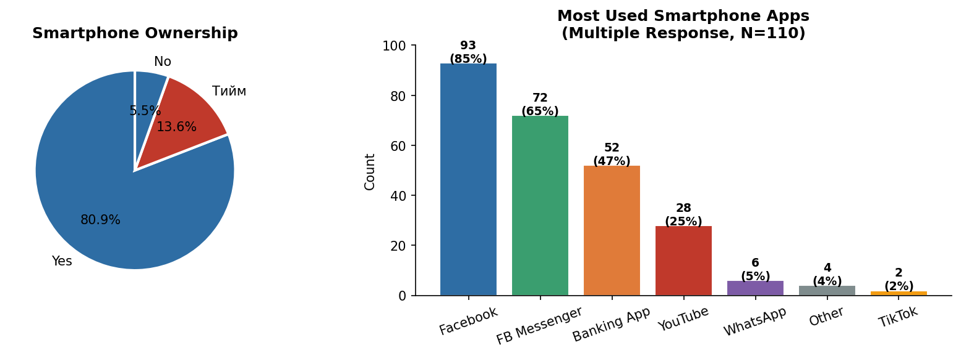
Figure 14. Smartphone ownership (left) and most used smartphone apps (multiple response, right).

8. Summary and Recommendations

8.1 Key Findings
- Herder profile: The sample is almost entirely composed of active herders (99%), with one-third also engaging in animal trading. Cashmere and livestock sales are near-universal income sources. Mean livestock holdings of ~200 animals are consistent with middle-income herder households.
- High financial inclusion: 84.5% report formal financial accounts, primarily through loan products. The prevalence of term loans and working capital loans suggests active credit use, though the dominance of family expense purposes (54.5%) may indicate loans are being used for consumption smoothing rather than productive investment.
- Strong digital connectivity: 88.2% own smartphones. Facebook dominates app use (84.5%), and nearly half use banking apps, indicating a mobile-ready population for digital financial and market information services.
- High asset ownership: Motorcycle (83.6%), car (75.5%), and truck (46.4%) ownership rates are high, consistent with the mobility needs of pastoral production systems.
- Pervasive network engagement: All seven network domains show strong engagement across the full sample, with mean scores between 1.31 and 1.90 on the 1–4 scale (1 = highest). This signals that these herder communities are well-networked and actively seek information and support across market, production, financial, and logistical channels. Both herder-only respondents and animal traders score within the strong engagement range, with traders showing slightly deeper engagement—particularly on livestock improvement and financial services networks.

8.2 Recommendations for Data Quality
- Standardize the income field: Use a numeric entry field with a dropdown currency/unit selector, or require values in a single unit (MNT). Eliminate free-text income entry.
- Standardize language: Yes/no responses appeared in both Mongolian and English. All survey fields should enforce a single language for categorical responses.
- Clarify the network scale: Document whether scores 1–4 represent ranked importance, frequency, or another dimension. The current variable label implies a 4-point scale but the response pattern suggests a ranking.
- Add date of birth validation: Implement a minimum age (e.g., 18) and maximum birth year (e.g., current year minus 18) constraint in KoboToolbox to prevent implausible entries.

Overall, the dataset is of good quality for a field survey of this type. With scaling up and minor data standardization improvements, it can support a more robust analysis of herder livelihoods, financial access, and network relationships in Mongolia.

